AT ONCE DUO - INDIVIDUAL BIOS

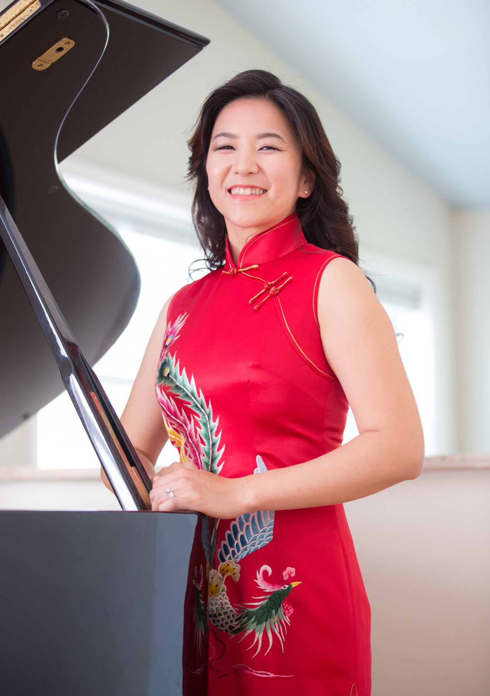
Pianist Yalin Chi made her début with the Central Opera Orchestra before moving to the United States to study at Interlochen Arts Academy. Yalin has performed at venues including Alice Tully Hall, Weill Recital Hall at Carnegie Hall, Kumho Art Hall in Seoul, Korea, and ZhongShan Music Hall in Beijing China. Her solo recital was selected by the Poughkeepsie Journal as one of the weekend top picks, and Leslie Gerber of the Woodstock Times described her recital in the Saugerties Pro Musica concert series as “flowing and masterful,” with “gorgeous tonal coloring.”
Yalin has worked with musicians around the world, including principal trombonist of the New York Philharmonic Joseph Alessi, principal trumpet of the London Symphony Orchestra Philip Cobb, clarinetist Alexander Fiterstein, and concertmaster of the Seoul Symphony Orchestra Wayne Lin. As an orchestral musician, she regularly performs with Albany Symphony, New Jersey Festival Orchestra, and has held the principal keyboard position at the Hudson Valley Philharmonic since 2014.
Yalin studied with Seymour Lipkin and Jerome Lowenthal at the Juilliard School where she earned both undergraduate and masters of music degrees, and continued studies with Peter Frankl at Yale School of Music before joining the West Point Band in 2008.

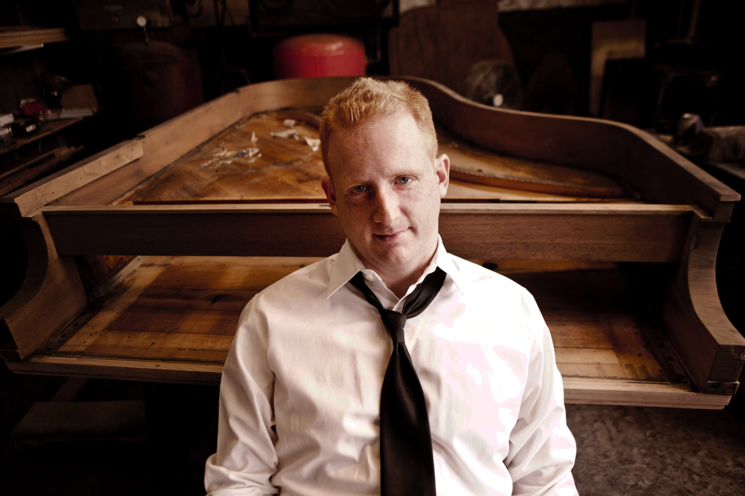
Pianist Steven Beck continues to gather acclaim for his performances and recordings. Recent career highlights include performances of Beethoven’s variations and bagatelles at Bargemusic, where he first performed the Beethoven sonata cycle.
Steven Beck is an experienced performer of new music, having worked with Elliott Carter, Pierre Boulez, Henri Dutilleux, Charles Wuorinen, George Crumb, George Perle, and Fred Lerdahl, and performed with ensembles such as Speculum Musicae and the New York New Music Ensemble. He is a member of the Da Capo Chamber Players, the Knights, and the Talea Ensemble. He is also a member of Quattro Mani, a piano duo specializing in contemporary music. As an orchestral musician he has appeared with the New York Philharmonic, the New York City Ballet Orchestra, Orpheus, the Mariinsky Orchestra and many others.
Mr. Beck’s discography includes Peter Lieberson’s third piano concerto (for Bridge Records) and a recording of Elliott Carter’s “Double Concerto” on Albany Records. He is a Steinway Artist.

